**Types of probabilities**

**Joint Probability**

When probability of combination of events has to be calculated hence such probability is called joint probability.

**Marginal Probability**

Probability of an event irrespective of any other event is called marginal probability.

**Conditional Probability**

Probability of an event given that some other event has already occurred.

**Probability Distributions**

Mapping of all possible values of random variables to their corresponding probability for a given sample space is called probability distribution.

**Note**: Probability distribution can be discrete or continuous depending on kind of random variables.

1. Discrete random variables give rise to discrete probability distributions.
2. For example probability of getting **2** when you toss a dice, similarly for other numbers. Hence such probability distribution will be discrete.
3. For discrete probability distribution, probabilities of sum of outcomes must be equal to 1 which can be written as ∑xf(x) = 1
4. The function f(x) is called **probability mass function** and gives probability that DRV is exactly equal to some value.
5. Hence using cumulative probability distribution we define range where probability distribution lies.
6. Simplest discrete variables are those which take only finite numbers of possible values with same probability.

**Types of Probability Distributions**

**Discrete Uniform Distribution**

Discrete uniform distribution is used under these conditions.

1. Minimum is fixed
2. Maximum is fixed
3. All values in range are equally likely to occur.

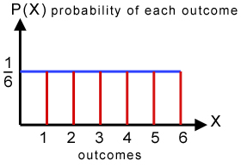

Discrete random distribution looks like this

**Note**: Here we can take example of throwing a dice a probability of occurrence of 1,2,3,4,5,6.

**Bernoulli Distribution**

Bernoulli distribution is the one in which the random variable can take only 2 values usually 0 and 1.

For example: when you toss a coin either head occurs or tails occurs, so it’s Bernoulli Distribution.



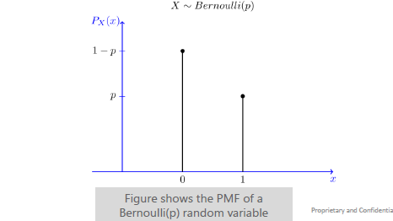

**Geometric Distribution**

For example: You toss a coin until first head occurs.

Here we define **x** as total number of times coin is tossed to get first head, x is said to have geometric distribution with parameter **p.**

In other words we can consider it as independent Bernoulli trails until observing first success.

Probability mass function for geometric distribution is defined as follows:

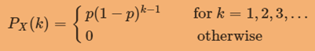

Where 0< p <1

Geometric Distribution is applicable if following assumptions are true:

* Phenomenon being modelled is a sequence of trials.
* There are only two possible outcome for each trial.
* The success p, is same for every trail.

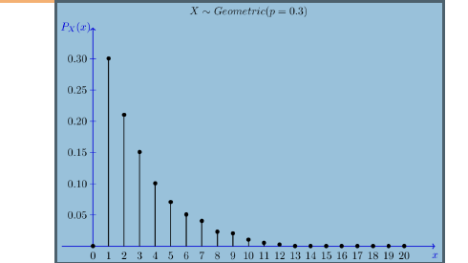

**Binomial Distribution**

Random experiment behind binomial distribution is as follows:

* Suppose we have a coin with P(H) =p and we toss the coin n number of times.
* We define x to be total number of head that occurred, then x is a binomial with parameter n and p

Which is given by:



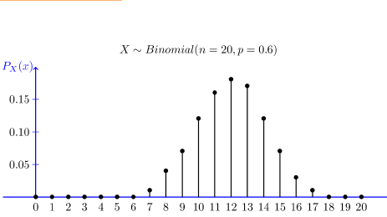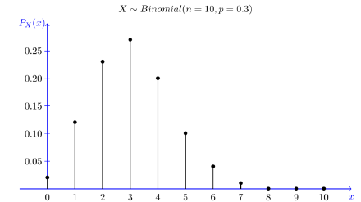

Binomial distribution is an appropriate model if following assumptions are true:

* A set of n trials are conducted
* Outcomes of different trails are independent.
* Each trail results in either success or failure.
* Probability p is same for all trials.
* We are interested in total number of success in all trails.

**Negative Binomial Distribution(PASCAL)**

Binomial distribution is an appropriate model if following assumptions are true:

* Pascal Distribution is generalization of Geometric Distribution.
* It is random experiment of repeated independent trails until m success.
* Random experiment when coin is tossed until m head occur whereas binomial distribution is the one in which number of time head occurred in n trails.
* Here X is defined as total number of coins tossed in the experiment.



0 < p <1

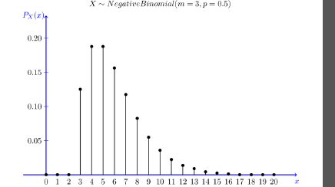

An experiment follows binomial distribution when following assumptions are true:

* An experiment consist of n independent trails.
* Each trial can result in either success or failure.
* Probability of success is constant for each trial
* Experiment continues until a total of r successes have been observed.

**Poisson Distribution**

It’s used when we are counting occurrence of an event in an interval of time or space.

It has single intensity parameter where both mean and variance (Poisson distribution) are same i.e. **lambda.**

**Suppose we want to calculate number of customers visiting a store between 2 PM to 9PM.**

**Based on previous data we know that average customer visiting the store is 15 but it won’t be same everyday.**

Here we may model Poisson distribution with lambda equal to 15.



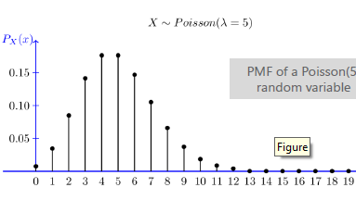

**Poisson distribution is appropriate if following assumptions are true:**

* k is number of times an event occur in an interval and k can take values 1,2,3,4 etc.
* Occurrence of an event does not affect the probability of occurrence of another event.
* The rate at which interval occur is constant, rate can’t be higher in some interval and lower in other.
* Two events can’t occur exactly at same instant.
* Probability of an event in small instant is proportional to length of the event.

Example: Number of phone calls arriving an exchange in a minute.

**Continuous Uniform Distribution**

* Continuous random variable gives rise to continuous probability distribution.
* Continuous distribution is sometimes called rectangular distribution, because this distribution has constant probability.

It can be represented as follows:



Mean and variance can be calculated as follows:



One major application of continuous uniform distribution is in sampling. In running stimulation experiments it’s necessary to generate pseudo random numbers from uniform distribution.

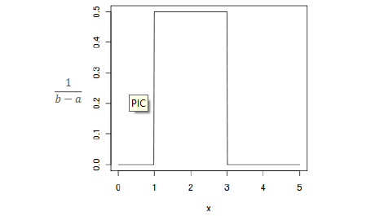

**Exponential Distribution**

It’s often used to model time elapsed in events.

Exponential distribution is defined as follows:



Most important property of exponential distribution is that it’s memoryless.

It’s defined as time interval between two events occurring.

For example if someone asks you to find time interval between two events **A** and **B**.

**Lambda**: Average number of events in one unit of time.

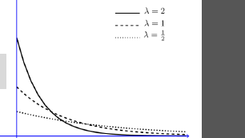

**Normal Distribution**

* Its bell shaped curve, which is observed in many real life phenomenon.
* Continuous frequency distribution of infinite range which is symmetric around the mean.
* Total area under the curve is total probability of 1
* Binomial distribution tends towards 1 when n increases.
* Normal distribution completely described by µ and standard deviation(SD)
* µ is the centre or mean and SD increases spread of the curve, more the SD more will be spread.



Normal distribution can be defined as:



Its range is (-∞, ∞)

We write x follows normal with mean µ and sd as:

